
Advice Officer - Money
Willowacre Trust
https://westscot.co.uk/recruitment/
WELCOME
Thank you for your interest in Willowacre Trust. This pack explains who we are, what we need from you and what you need to do to apply.
As the charitable subsidiary of West of Scotland Housing Association (WSHA), Willowacre Trust’s overarching aim is to tackle social and economic disadvantage and impact on tenancy sustainment within the communities served by WSHA. We want a staff team and Board that shares our values and puts customers at the centre of service delivery.
Our staff are at the heart of our business and we support them to be their best which is demonstrated with 84% of staff saying Willowacre Trust and WSHA is a good place to work.
We are an equal opportunities employer and positively encourage applications from suitably qualified and eligible candidates regardless of sex, race, disability, sexual orientation, age, or religion or belief. We are particularly interested to hear from applicants with a disability, or from a black, asian or minority ethnic background.
Disabled applicants who meet the essential criteria will, where possible be granted an interview under the Disability Confident scheme.
We are committed to achieving high standards of quality in recruitment and to ensuring that our appointments are made solely on the basis of merit and that you are treated in a fair and equitable manner.
We look forward to receiving your application.

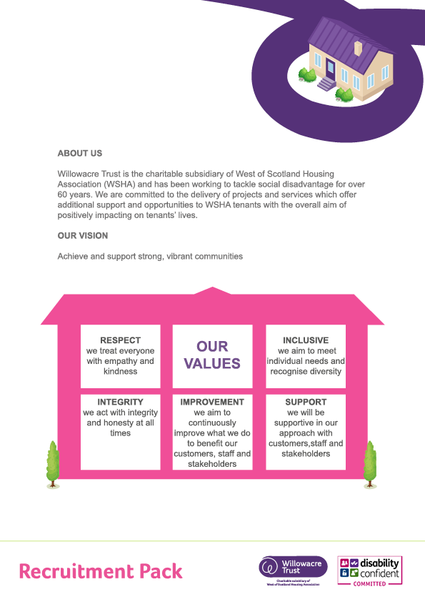
To ensure our values are reflected in everything we do, we have created a
Values Framework which outlines the behaviours expected of our staff, managers and Board.


WORKING FOR US
Free access to a comprehensive Employee Support and Wellbeing Service
Access to a personal health care plan for you and your family

Access to staff shopping discounts as well as salary sacrifice staff tech and EV scheme

Friendly, inclusive environment and
with the flexibility of a hybrid model of working
(mix of home and office) if the role allows.

Generous holiday allowance of 40 days
Strong focus on staff wellbeing including
free flu jabs and annual health checks
Cycle to work Scheme and secure bike shed at office.



Pension:

We offer a Scottish Widows defined contribution scheme provision to all staff employed by Willowacre Trust.

The employee can contribute a minimum of 3% to the scheme.

The employer will contribute twice the employee contribution to a maximum of 10%.

Our pension scheme contributions are based on a salary sacrifice arrangement whereby the employer gives 100% of NI savings to the employee.

In addition to the above, we also provide staff with Critical Illness cover
and Life Cover x 3 salary.






We are looking for a new Advice Officer - Money who shares our values and will use them to guide the way they work on a daily basis.
The Advice officer will offer support to people, particularly older people who are struggling financially and who reside in the communities served by WSHA. This is an integral role within the team, and the postholder will be expected to embrace taking a holistic approach to supporting customers.
You should:
• Be able to carry out a comprehensive assessment of individual customer’s needs, detailing in a coordinated support plan what actions need to be completed to help address issues or difficulties they are facing.

• Be skilled in providing money management, debt and budgeting advice services to individuals and groups, including online banking, household bills, understanding financial liability and price comparisons.

• Have a flexible and methodical approach to organising and prioritising a high-volume caseload
• Have a good understanding and ability to assist customers onto repayment programmes, including negotiating and liaising with creditors on customer’s behalf. Make appropriate referrals to specialist agencies for Protected Trust Deeds, Bankruptcy and the Debt Arrangement Scheme and any other appropriate debt solutions

ABOUT THE ROLE
Job Title: Advice Officer – Money
Department: Community Services
Location: Glasgow, G40
Salary Scale: WT Grade 4 £30,248 per annum


MAIN RESPONSIBILITIES
- Carry out a comprehensive assessment of individual customer’s needs, detailing in a coordinated support plan what actions need to be completed to help address issues or difficulties they are facing
- Provide information and advice to customers on a wide range of topics and issues
- Provide money management, debt and budgeting advice services to people individually and in group settings, including online banking, household bills, understanding financial liability and price comparisons.
- Provide advice and information on safe borrowing and savings options as an alternative to high-risk borrowing.
- Have a good understanding of the issues facing older people and ways to address these
- Have a good understanding and ability to assist customers onto repayment programmes, including negotiating and liaising with creditors on customer’s behalf
- Make appropriate referrals to specialist agencies for Protected Trust Deeds, Bankruptcy and the Debt Arrangement Scheme and any other appropriate debt solutions.
- Maximise customer income by sourcing and applying for individual grant funding and debt relief funds.
- Carry out basic benefit checks/provide entitlement advice through home visits, accessible community settings, digitally, office appointments and telephone enquiries
- Manage a high-volume caseload, ensuring that assessment needs of customer and case management files and database are kept up to date.
- Be proactive and creative in your approach to communication with customers including telephone, customer app, email, group settings and one to one home visits.
- Develop and deliver financial information workshops on topics such as ‘fraud awareness,’ ‘online shopping,’ ‘using apps for convenience,’
- Refer customers for income maximisation support to WSHA Welfare Benefits Team
- Participate in and support good communication across internal teams.
- Provide practical support to customers through the provision of goods such as starter packs, upcycled white goods and furniture and food parcels.
- Understand service outcomes and fully contribute to achieving service targets as set in WT Business Plan
- Maintain systems and procedures for the delivery, monitoring and evaluation of the Money Advice Service using Advice Pro Case management system and case studies
- Contribute towards the production of publicity and training materials on debt, credit or money management for customers and staff at Willowacre Trust & WSHA
- Support Willowacre Trust and WSHA to tackle economic inequality
- Ensure procedures are followed in relation to PeopleSafe guidelines and lone working policy
- Ensure data is managed to timescales and in accordance with the organisation’s policy and GDPR requirements
- Undertake any other reasonable duties as requested by line manager

The list above is typical of the level of duties which the post holder is expected to perform or be responsible for. It is not necessarily exhaustive and other duties of a similar type and level may be expected from time to time.


Essential Criteria - Applicants are required to meet all essential criteria to be considered for shortlisting. Where an essential criterion is highlighted in bold, a higher weighted score will be given to applicant’s attitude in that area.
Assessment Method -Applicants should note that the method of assessing individual applications is given in the assessment column (ASS Method) as follows: AF – Application Form; I-Interview, P – Presentation, PSY – Psychometric testing

Criteria - Skills & Qualities | Assess  Method | E | D
Ability to maintain written records, complete forms and to work accurately with budgetary figures | AF/I | *
Excellent interpersonal and engagement skills with the ability to liaise, negotiate and build relationships with customers and agencies through multiple media (face to face, customer app, telephone and email). | I | *
Competent IT skills in Microsoft Word, Outlook, Excel including experience of using Case Management Systems such as Advice Pro | AF/I | *
Flexible and methodical approach to organising and prioritising a high-volume caseload through effective time management | AF/I | *
Excellent ability to work well under pressure and to agreed timescales to meet targets | AF/I | *
Ability to maintain confidentiality incorporating GDPR principles | AF/I | *

Experience & Knowledge | Assess Method | E | D
Experience of working with individuals to develop outcomes based support plans which promote financial and social inclusion, supporting increased health and wellbeing | AF/I | *
Knowledge and understanding of issues facing older people and how to support them to achieve good outcomes | AF/I | *
Experience of providing money management, debt and budgeting advice services to customers tenants individually and in group settings, including online banking, household bills, understanding financial liability and price comparisons | AF/I | *
A good understanding and ability to assist customers onto repayment programmes, including negotiating and liaising with creditors on customer’s behalf. | AF/I | *
Experience of making appropriate referrals to specialist agencies for Protected Trust Deeds, Bankruptcy and the Debt Arrangement Scheme and any other appropriate debt solutions. | AF/I | *
Experience of delivering a money advice / financial information workshops | AF/I |  | *
Experience of maximising customers income by sourcing and applying for individual grant funding and debt relief funds | AF/I |  | *

PERSON SPECIFICATION CRITERIA

Other Requirements | Assess Method | E | D
Have a full Driving Licence | AF | *
Ability to work occasional flexible hours when required (Evenings/Weekend) | AF | *
This post is subject to a satisfactory Disclosure Scotland Check | AF | *

Demonstration of the Values | Assess Method | E | D
Respect - Treats everyone with empathy and kindness | I | *
Inclusive – Aims to meet individual needs and recognise diversity | I | *
Integrity - Acts with integrity and honesty always | I | *
Improvement- Aims to continuously improve what we do to benefit our customers, staff, and stakeholders | I | *
Support - Supportive in your approach to customers, staff, and stakeholders | I | *

PERSON SPECIFICATION CRITERIA
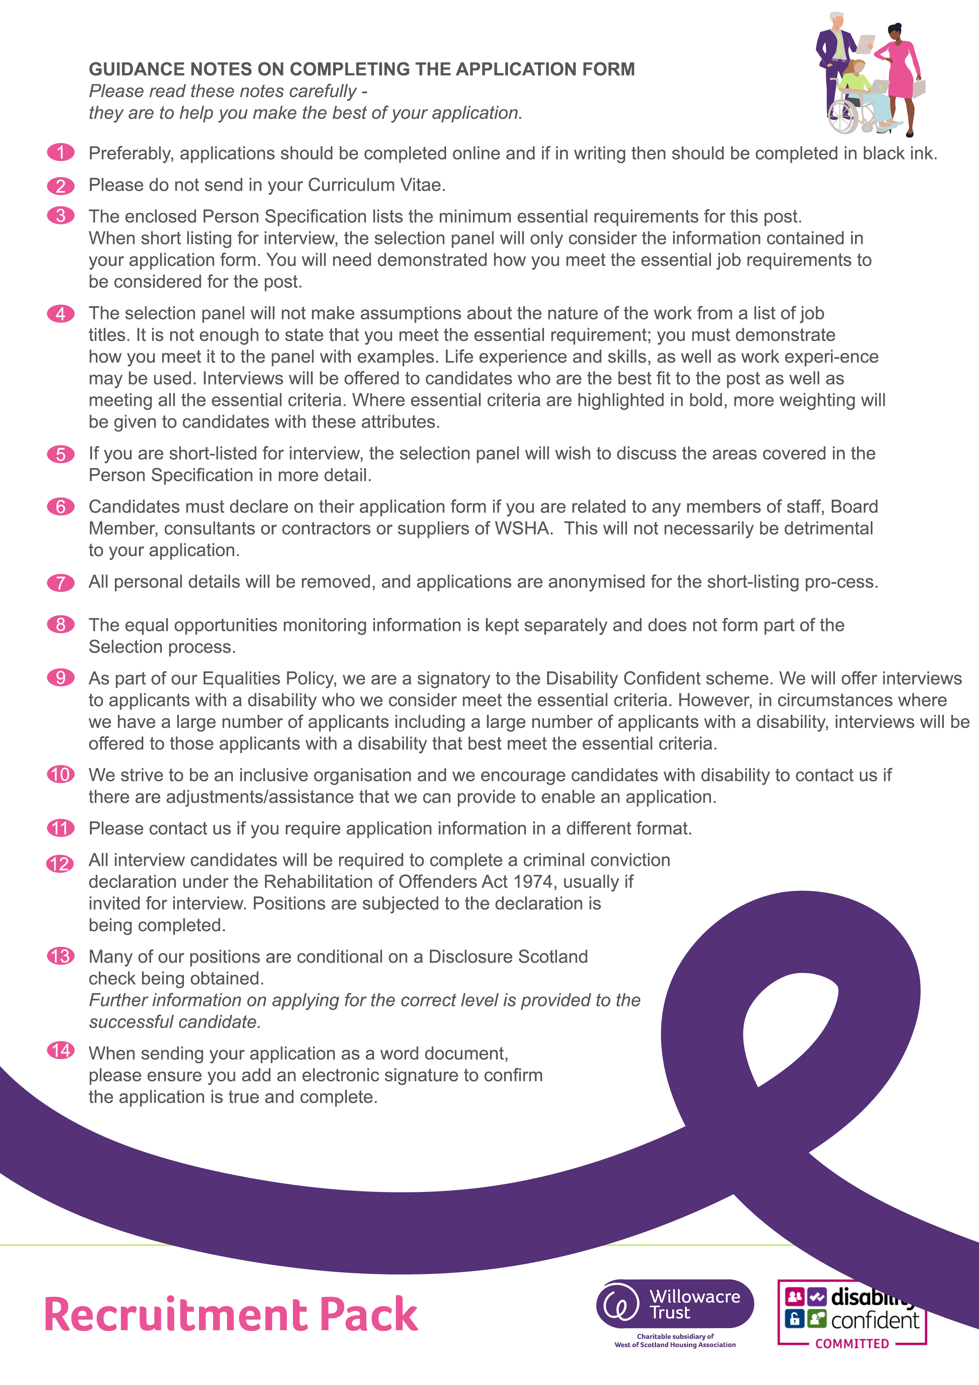
You should complete all sections of the application form and you will need to demonstrated how you meet all the essential job requirements on the person specification to be considered for an interview. Applications being completed using ChatGPT or similar AI technology will generally not be accepted and where this is suspected the application may be removed on receipt, from the process. You should also note that curriculum vitae, cover letters and supplementary material will not be considered.
Willowacre Trust does not provide visa sponsorship. All applicants must have the right to work in the UK to apply for positions. Any offer of employment will be conditional upon verifying documentary evidence of right to work in the UK before employment commences
Applicants with a disability are welcome to contact us regarding any adjustments, you require to the process.
Completed applications must be returned by Tue 28th October @ 12 noon
PROVISIONAL INTERVIEW DATE: Wednesday 5th November 2025
APPLICATION PROCESS
For further details and to apply online visit www.westscot.co.uk/about-us/recruitment/.
If you require an application in another format please email vacancies@westscot.co.uk or phone 0141 550 5600.
Late applications will not be considered. Applications submitted by email will receive an acknowledgement by return. If you would like us to acknowledge receipt of your posted application, please enclose a stamped addressed envelope with your completed application form
Equal Opportunities

We value diversity in our workplace and we would encourage
everyone who has the necessary skills and experience to apply.

Information given on the equal opportunities form will be treated in strictest confidence and will be retained for monitoring purposes.

It will be kept separately from your application form and will not be made available to those involved in the selection decision.

As part of our Equalities Policy, we are a signatory to the Disability Confident scheme. We will, where possible, offer interviews to applicants with a disability who we consider meet the essential criteria.

If you are unhappy with any part of the recruitment and selection procedure, you should contact the telephone number or our email address, given in the advertisement initially.

If you are still dissatisfied, you can request and make a formal complaint using our Comments, Complaints and Compliments procedure or if an internal applicant, through our grievance process.

