

Information and Application pack for Provanhall Housing Association

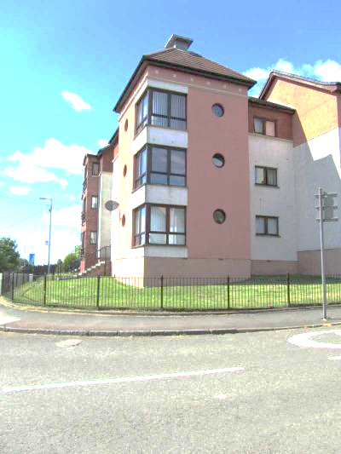
Board Membership

Contents

Welcome! 3
Provanhall Housing Association – an overview 4
Business plan 7
Becoming a Board Member 7
Primary Responsibilities 7
Main Tasks 8
Duties 8
Commitment 9
What Provanhall Housing Association Offers Board Members 9
Eligibility Declaration 13
Application Form 17
Equality, Diversity & Inclusion Monitoring Form 19

Welcome!

Thank you for your interest in getting involved with Provanhall Housing Association. Our success depends on having a committed and knowledgeable Board, and we’re excited to offer you the chance to play an important role in shaping our future.
As a Board Member, you’ll help set high-level policies and take part in strategic discussions for a local Registered Social Landlord at the heart of our community.
Right now, we face challenges such as rising costs and the impact of the cost of living on our tenants. This means we need to work smarter and make the best use of our resources. It’s a demanding time but also an incredibly rewarding and interesting one.
Our Board is central to these decisions, helping guide our direction and ensure we continue to serve our community effectively. If this sounds like something you’d like to be part of, please read on.
This pack includes:
- More information about Provanhall Housing Association
- Details about the role of Board Members
- An application form
You can also find more about us on our website: www.provanhallha.org.uk
If you have any questions about the role or the application process, please contact Alan Hume on 0141 771 4941 or email info@provanhallha.org.uk
We look forward to receiving your application.



Alan Hume Linda Cameron
Chief Executive Chairperson

Provanhall Housing Association – an overview

PHA’s roots go back to the 1950s when Glasgow Corporation followed a policy of large-scale slum clearance in the inner city and the creation of a new generation of council houses on the city’s outer edges. Easterhouse was built from the mid-1950s onwards to house a population of 50,000 people and was the largest of the new estates that were built.

By the 1980s, many communities in Easterhouse including Provanhall had serious housing and social problems which the City Council was unable to resolve. A new breed of community-controlled housing associations emerged in Easterhouse – Provanhall among them - which became landlords, developers, and managers of housing. Led by local residents, the Easterhouse housing associations exemplified “people power” in action and became part of a citywide movement of similar organisations which acted as renewal agents in communities throughout Glasgow. The longevity of the Easterhouse associations tells its own story of why local solutions work and is testament to the many Easterhouse residents who have served on boards without payment for the good of their community.

PHA’s initial focus was on improving the quality and sustainability of housing, by renovating existing homes and building new ones. The new build element of the regeneration has helped to increase diversity in house types and sizes.

A second wave of growth occurred in 2009, when Glasgow Housing Association finally completed the transfer of 195 homes to the Association, following a six-year transfer process. This Community controlled housing association, set up in 1991 Registered Social Landlord with charitable status established PHA as the owner and manager of all social rented housing in Provanhall, although Glasgow Housing Association (GHA) has since built 2 new build developments in Provanhall. PHA secured a role in the second of these developments, taking ownership of 26 completed homes during 2019/20 and 2020/21. Community governance has been part of the Association’s DNA throughout its history. The leadership provided by local people has contributed to sustainable regeneration, better long-term value for public money, and a wide range of other achievements.

We continue to work with, and develop, Easterhouse Housing and Regeneration Alliance (EHRA), the partnership of the 8 local Community Based Housing Associations in Easterhouse. We undertake a lot of joint lobbying and training in partnership with them.

We do not have any shareholders, so all surplus is re-invested in delivering services for our tenants and community.

Our stock is a mix of general family homes, amenity houses and wheelchair houses and flats. We also provide a factoring service to owner occupiers in our area. Our area of operation is detailed on this map.


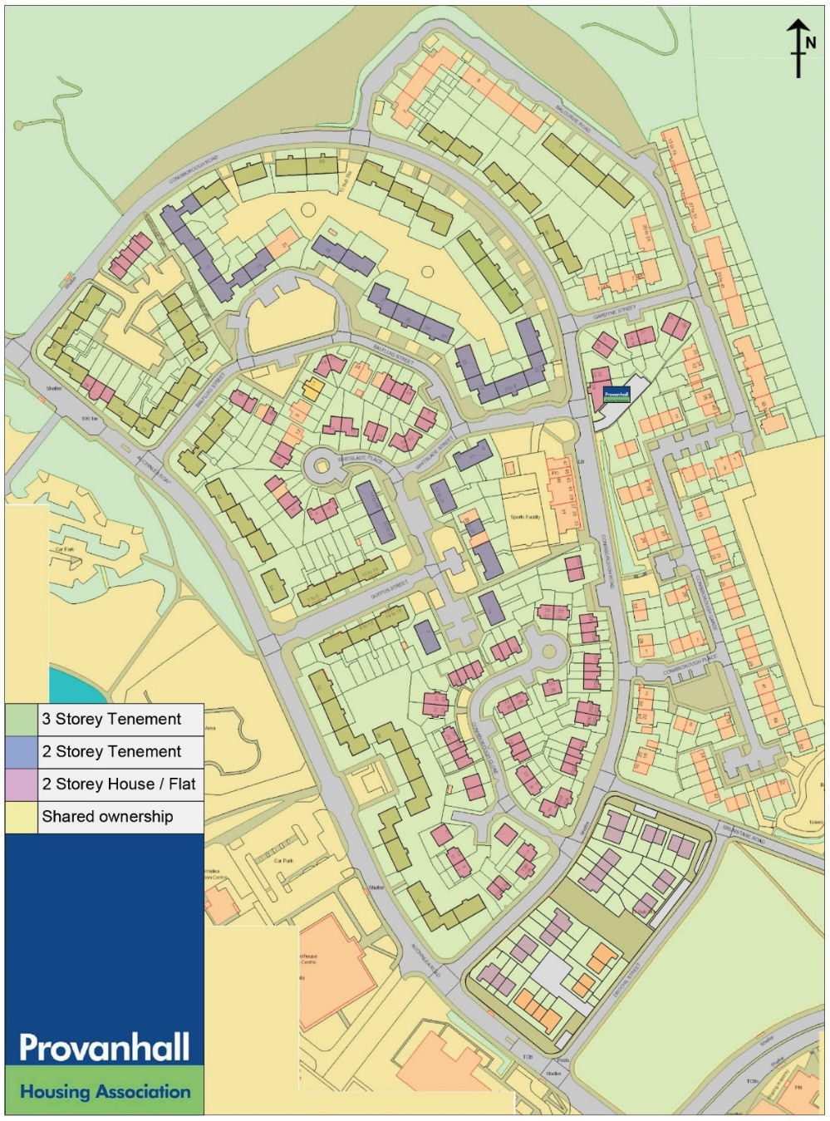

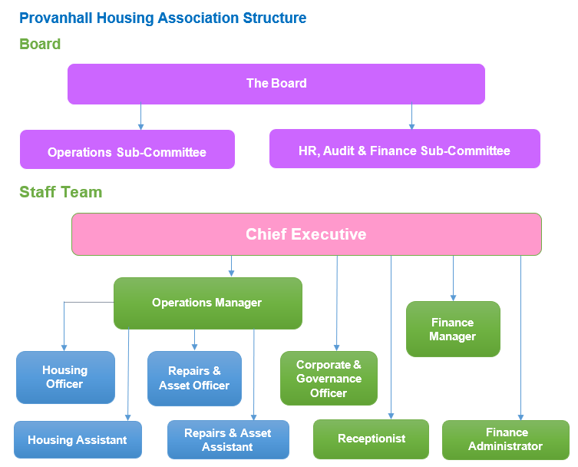

Business plan

In accordance with requirements of the Scottish Housing Regulator, Provanhall Housing (Provanhall) developed a 30 year business plan which is published on our website at http://www.provanhallha.org.uk/governance or from our offices by request.

Becoming a Board Member

Are you passionate about making a real difference? Do you want to help define the strategy of a community lead housing association – then please read on!

Before committing to becoming a member of our Board there are a few matters to set out for your consideration.

This role description has been prepared to set out the responsibilities that are associated with being a member of the governing body of Provanhall. It should be read in conjunction with Provanhall’s Rules and Standing Orders.

As a Registered Social Landlord and a Scottish Charity, the role description reflects the principles of good governance and takes account of (and is compliant with) the expectations of the Regulatory Standards of Governance and Financial Management for Scottish RSLs and relevant guidance produced by the Office of the Scottish Charity Regulator (OSCR).
Provanhall encourages people who are interested in the Association’s work to consider seeking election as a member of the Governing Body (GB) and is committed to ensuring broad representation from the communities that it serves.
Whilst Governing Body Members (GBMs) do not require ‘qualifications’, from time to time, we will seek to recruit people with specific skills and experience to add to or expand the range of skills and experience available to ensure that the GB is able to fulfil its purpose. We carry out an annual review of the skills that we have and those that we need to inform our recruitment activities, and we have set these out in a GBM Profile.
This role description applies to all members of the GB, whether elected or co-opted, new or experienced. It is subject to periodic review.

Primary Responsibilities

Our GBM’s primary responsibilities are:
- Lead and direct Provanhall’s work
- Promote and uphold Provanhall’s values
- Set and monitor standards for service delivery and performance
- Control Provanhall’s affairs and ensure compliance

Responsibility for the operational implementation of Provanhall’s strategies and policies is delegated to the Chief Executive.
Provanhall has agreed a Code of Conduct for GBM’s which every member is required to sign on an annual basis.
Each member must accept and share collective responsibility for the decisions properly taken by the GB. Each GBM is expected to contribute actively and constructively to the work of Provanhall. All members are equally responsible in law for the decisions made.
Each member must always act only in the best interests of Provanhall and its customers, and not on behalf of any interest group, constituency or other organization. GBM’s cannot act in a personal capacity to benefit themselves or someone they know.

Main Tasks
- Contribute to formulating and regularly reviewing Provanhall’s values, strategic aims and performance standards
- To monitor Provanhall’s performance
- To ensure that Provanhall operates within and is compliant with the relevant legal and regulatory frameworks
- To ensure that risks are realistically assessed and appropriately monitored and managed
- To ensure that Provanhall is adequately resourced to achieve its objectives and meet its obligations

Duties
- Always act in the best interests of Provanhall
- Accept collective responsibility for decisions, policies and strategies
- Attend and be well prepared for meetings of the GB and sub-committees
- Contribute effectively to discussions and decision making
- Take part in training and other learning opportunities
- Take part in an annual review of the effectiveness of Provanhall’s governance and of the members’ individual contribution
- Maintain and develop personal knowledge of relevant issues and the wider housing sector,
- Represent Provanhall positively and effectively in local communities and when attending meetings and other events
- Respect and maintain confidentiality of information
- Treat colleagues with respect and foster effective working relationships within the GB and between the GB and staff
- Attend and participate in reviews of GBM’s performance, and in an annual review of your individual contribution to Provanhall’s governance
- Be aware of and comply with the restrictions on Entitlements, Payments and Benefits
- Register any relevant interests as soon as they arise and comply with Provanhall’s policy on managing conflicts of interest

Commitment

An estimate of the annual commitment expected from GB Members:
Activity | Time
Attendance at up to 10 x 1.5 hours regular meetings of the GB | 15
Reading and preparation for GB meetings 10 x 1.5 hours | 15
Attendance at sub-committee meetings (8 x 30 minute meetings)  - Operations, Quarterly, before GB meetings  - HR, Finance & Audit, Quarterly, before GB meetings | 4
Reading and preparation for sub-committee meetings | 4
Attendance at Annual General Meeting (AGM) | 2
Attendance at annual planning and review events (including individual review meeting) | 20
Attendance at openings and site visits | 2
Attendance at internal briefing and training events | 7
External / Online Training and conference attendance (may include overnight stay or weekend) | 21
Total | 90

What Provanhall Housing Association Offers Board Members

All members of the GB are volunteers and receive no payment for their contribution. Provanhall HA has policies which prevent GBM’s or people they are closely connected to benefitting from their involvement with Provanhall HA, although they also seek to ensure that GBM’s are not unfairly disadvantaged by their involvement with Provanhall HA. All out of pocket expenses associated with the role of being a GBM are fully met and promptly reimbursed.

In return for the commitment offered by GBM’s, Provanhall HA offers:
- A welcome and introduction when a Member first joins the GB
- A mentor from the GB and a named staff contact for the first six months, with ongoing support
- Clear guidance, information and advice on GBM responsibilities and on Provanhall HA’s work
- Formal induction training to assist settling in
- Papers which are clearly written and presented, and circulated in advance of meetings in a format that is suitable for you
- The opportunity to put members’ experience, skills and knowledge to constructive use
- The opportunity to develop members’ own knowledge, experience and personal skills
- The chance to network with others with shared commitment and ideals.
Board Member Profile
Qualities
Commitment to:
- the aims, objectives and values of Provanhall HA
- the local community
- the voluntary housing sector
- equalities

Skills:
- willing to listen and take advice
- able to deal with complex information
- able to question and debate
- willing to express opinions
- able to co-operate and compromise
- able to contribute to effective decision-making
- understanding and respect for other views
- respect for and trust in colleagues and staff
- able to accept collective responsibility
- able to give and take constructive criticism
- able to give sufficient time
- willing to put personal interest aside
- able to use own knowledge for PHA’s benefit
- able to assess the impact of decisions

Knowledge (one or more of the following)
knowledge of PHA’s community:
- housing
- environment
- people
- expectations
- wider role
- finance (housing or broader)
- housing management
- property management / maintenance
- legislation and policies
- local government
- employment responsibilities / HR
- Scottish Housing Regulator
- OSCR

Experience (one or more of the following)
- living or working in Easterhouse
- being a tenant
- community activities
- regeneration
- being a member of a board
- engaging with other boards
- role and contribution of housing associations
- monitoring performance and / or benchmarking
- business / strategic planning
- corporate / business management

Essential Personal commitments
- interest in the well-being of the local community
- willing to attend training events and conferences
- turn up to meetings on time
- respect the confidentiality of the business of the Association during their time as a Board member and after they cease to be a Board member
- work for the benefit of the group without personal interest
- contribute to the work of the Association without personal interest
- contribute to the work of the Association in a courteous manner
- work hand in hand with staff
- Issues and grievances from outside should not influence contribution to Board workings

The Chairperson
It is the Chairperson's responsibility to:
- ensure meeting are run competently
- ensure discussion and decision-making is democratic
- safeguard the rules of the organization
- Speak on behalf of the organization

The Secretary
The Secretary is responsible for the administrative tasks involved in the operation of the organization including:
- correspondence and records
- membership lists
- keeping minutes
- preparing agendas
- preparing for the Annual General Meeting
- must follow the agreed policies and procedures of Provanhall Housing Association

Process for joining the Board
- The individual expresses an interest by applying. To do this the individual needs to complete the following three forms (which are included in this pack) and return to our office:
  - Eligibility Declaration Form
  - Application Form
  - Equality, Diversity & Inclusion Monitoring Form
- Our Chairperson and Chief Executive meet with the applicant to discuss their application and answer any questions
- Approval or rejection of application made within five working days of the meeting

Eligibility Declaration

Guidance Note for Applicants and Board Members

This note explains the key terms and requirements in the Eligibility Declaration. It is designed to help you confirm your eligibility with confidence.

1. Criminal Convictions and Investigations

Unspent convictions: These are convictions that must still be declared under the Rehabilitation of Offenders Act 1974. If your conviction is “spent,” you do not need to declare it.

Dishonesty, fraud, or financial misconduct: Any conviction for these offences (if unspent) will disqualify you.

Under investigation: If you are currently being investigated (or subsequent after appointment) for criminal activity, you cannot serve or must immediately report to the Chief Executive to request a leave of absence until the matter is resolved.

2. Bankruptcy and Insolvency

If you have been declared bankrupt, entered into a trust deed, or had your estate sequestrated, you must have been formally discharged.

This applies worldwide, not just in Scotland or the UK.

3. Disqualification from Roles

Company directors: Courts can disqualify individuals from acting as directors under the Company Directors Disqualification Act.

Charity trustees: You cannot serve if you have been removed or disqualified from charity management under Scottish or UK law.

4. Removal from Boards

If you have been removed from the board of another housing association or charity due to misconduct, you are not eligible.

If you resigned after being notified of a meeting to consider your removal, this also counts as disqualification.

5. Attendance and Commitment

Board members must be able to attend meetings regularly. If you know you will be unable to attend for 12 months, you cannot serve.

6. Barred Lists

If you are on a barred list (such as the Protection of Vulnerable Groups (PVG) scheme), you cannot serve.

7. Conflicts of Interest

A conflict of interest means any personal, financial, or professional interest that could prevent you from acting in the best interests of the Association.

Examples: owning a company that contracts with the Association, or having close family employed by the Association.

Eligibility Declaration for Board Members

To be eligible for election to the Board of Provanhall Housing Association you must confirm your eligibility in line with the undernoted rules:

Association Rules (Rule 43)

43.1.1: You have not been adjudged bankrupt, granted a trust deed, entered into an arrangement with creditors, or had your estate sequestrated without discharge.

43.1.2: You have not been convicted of an offence involving dishonesty which is not spent under the Rehabilitation of Offenders Act 1974, or of an offence under the Charities and Trustee Investment (Scotland) Act 2005.

43.1.3: You are not a party to any legal proceedings in any Court of Law by or against the Association.

43.1.4: You are not, and will not be, unable to attend Board or Committee Meetings for a period of 12 months.

43.1.5: You have not been removed from the Board or Committee of another registered social landlord within the previous five years.

43.1.6: You have not resigned from a Board or Committee in circumstances where resignation followed notice of a special meeting convened to consider removal (Rule 44.5).

43.1.7: You have not been removed from the Board or Committee in terms of Rules 44.4 or 44.5 within the previous five years.

43.1.8: You have not been removed, disqualified, or suspended from a position of management or control of a charity under Scottish or UK law.

43.1.9: You have not been removed from the office of charity trustee or trustee for a charity by order of the Charity Commissioners for England and Wales or the High Court of Justice in England.

43.1.10: You are not subject to a disqualification order or undertaking under the Company Directors Disqualification Act 1986 or equivalent legislation.

Additional Governance Standards

I am not currently under investigation for any criminal activity in any jurisdiction.

I have no unspent criminal convictions.

I have never been convicted of dishonesty, fraud, or financial misconduct.

I am not on any barred lists (including the Protection of Vulnerable Groups (PVG) scheme or equivalent).

I have no conflicts of interest that would impair my ability to serve impartially.

Declaration of Truth

Providing false or misleading information may result in removal from the Board and/or criminal proceedings.

I confirm that none of the above disqualifications apply to me. I understand that:

- Providing false or misleading information may result in removal from the Board and/or criminal proceedings.

- The Association may verify the information provided.

- This declaration forms part of the governance records of Provanhall Housing Association.

Signature Section

Applicant name ………………………………………………………

Applicant signature ……………………………………………

Date ………………………….

Application Form

BOARD MEMBER APPLICATION
CONFIDENTIAL WHEN COMPLETED

This form should be completed by members of Provanhall Housing Association who wish to stand for election to the Board. When completing the form, please refer to the Application Pack which contains a description of the responsibilities that apply to Board Members and information about the skills and knowledge that Provanhall is particularly looking for.
Name | Title:  First Name:  Surname:
Address

Postcode
Mobile number

Email address
Are you a member of Provanhall Housing Association | If YES, how long have you been a member:
Are you a current tenant of Provanhall Housing Association? | YES/NO
Are you related to anyone who is already a member of Provanhall’s Board or to someone who is employed by Provanhall? | If YES please provide relative’s name:
Are you involved with any business that provides services or is contracted to Provanhall? | If YES please provide details:
Are you employed? | If YES please provide details of what you do and who you work for:
Please describe why you are interested in joining Provanhall’s Board?

Please describe how your experience would help you carry out the duties described in the statement of responsibilities for Board Members (a copy is in the Application Pack)

Are you willing and able to attend training on a regular basis?

Please provide details of two people who would be happy to recommend you to the position of Board Member. They CANNOT be family members or friends.
Person 1  Title:  First Name  Surname: | Person 2  Title:  First Name  Surname:
Postal Address: | Postal Address:
Contact number:  Email address: | Contact number:  Email address:
How do they know you:  (Cannot be a family member or friend) | How do they know you:  (Cannot be a family member or friend)

If selected for interview, do you require any assistance to attend and participate in the interview? Yes/No. If ‘Yes’ please provide details in the box below:

I confirm that I have read the Board Member’s Role Description, Profile and Eligibility Form and that I am eligible to stand for election.
Signature ………………………………………………………………….
Date ………………………………………………

Equality, Diversity & Inclusion Monitoring Form

Information for those completing the form

Why are we asking for equality information?

We collect equality information to help us to plan and deliver effective services and to meet our legal and regulatory obligations.

What do we do with equality information?

We use equality information for a range of purposes, including to help us to:
- protect and promote your rights and interests
- promote equality objectives across our services
- identify and address our customers’ needs, and improve our services
- identify and eliminate any form of discrimination

Do you need to answer every question?

By answering as many questions as possible you will help us meet your needs better, but we provide options throughout this form to allow you to provide only the information you want to give us. You can complete some questions and not others or you can complete parts of questions. The form has space for you to tell us more about your needs if you want.

We may ask for some information in other forms where this is required by law. For example, where we need to know your age if you are applying for a home as only those over 16-years-old can be registered on our housing list.

Are the answers I provide anonymous?
Yes – the answers you provide are completely anonymous and will not be linked back to you in any way.

Who do we gather equality information about?

We gather equality information from:
- people who apply for a home
- tenants
- people who apply for a job with us
- our employees
- board members
- elected members (in case of local authorities)

Other formats: We can provide this document in large print or other community languages. Please get in touch with us by email to info@provanhallha.org.uk or by text to 07723 402 317

Age

Please tick the band for your age: | 16–24 |  | 25–34
Please tick the band for your age: | 35–44 |  | 45–54
Please tick the band for your age: | 55–65 |  | 65+
Prefer not to say

Belief or religion

Please tick the box which best describes your belief or religion from the list below?

Buddhism:
Christianity
Catholic: |  | Protestant: |  | Other:
Hinduism:
Islam:
Judaism:
Sikhism:
Other religion (please state what this is):
No specific belief in religion (for example, atheism or agnosticism):
Other belief (for example, humanism):
Prefer not to say

Disability

Are you a disabled person? | Yes |  | No

If yes, please tick the box which category you would use from the following list:

Autoimmune: (for example, multiple sclerosis, HIV, Crohn’s/ulcerative colitis)
Learning difficulties: (for example, Down’s Syndrome)
Mental health issue: (for example, depression, bi-polar)
Neuro-divergent condition: (for example, autistic spectrum, Dyslexia, dyspraxia)
Physical impairment: (for example, wheelchair-user, cerebral palsy)
Sensory impairment: (hearing impairment)
Sensory impairment: (visual impairment)
Other: If none of the categories above apply to you, please specify the nature of your impairment.
Prefer not to say

Please tick all that apply
Are you a current Tenant? | Yes |  | No
Are you a current member of Staff? | Yes |  | No
Are you a current Board Member? | Yes |  | No

Ethnicity

Please tick the box that best describes your particular group.

African
African, African Scottish or African British:
Other African background (please specify):

Asian, Scottish Asian or British
Bangladeshi, Bangladeshi Scottish or Bangladeshi British:
Indian, Indian Scottish or Indian British:
Pakistani, Pakistani Scottish or Pakistani British:
Chinese, Chinese Scottish or Chinese British:
Other Asian background (please specify):

Black or Caribbean
Caribbean, Caribbean Scottish or Caribbean British
Black, Black Scottish or Black British
Other Caribbean or Black background (please specify)

Mixed groups
Mixed or multiple ethnic group (please specify)

White
English
Gypsy Traveller
Irish
Polish
Roma
Scottish
Welsh
Other British

Other group: | Yes |  | No
Please specify your ethnic group

Prefer not to say:

Marriage and civil partnership

Are you presently in a civil partnership? | Yes |  | No
Are you presently married? | Yes |  | No
Prefer not to say

Pregnancy and maternity

Are you pregnant? | Yes |  | No
Have you taken maternity or paternity leave in the past year? | Yes |  | No
Prefer not to say

Please use the space below to advise us if you have any particular requirements.

Please tick here if you want to discuss this matter in confidence:

Sex

What is your sex? | Female |  | Male |  | Intersex
Prefer not to say

Please use the space below to advise us if you have any particular requirements.

Please tick here if you want to discuss this matter in confidence:

Gender re-assignment (trans/transgender)

Do you consider yourself to be a trans person? | Yes |  | No
Prefer not to say

Please use the space below to advise us if you have any particular requirements.

Please tick here if you want to discuss this matter in confidence:

Sexual orientation

What is your sexual orientation?
Bisexual
Gay man
Heterosexual/straight
Lesbian/gay woman
Other
Prefer not to say

Please use the space below to advise us if you have any particular requirements.

Please tick here if you want to discuss this matter in confidence:

General

If you want to discuss something with us in confidence, please note your contact details here:

Please return your completed form to

Provanhall Housing Association
34 Conisborough Road
Easterhouse
Glasgow
G34 9QG

If you have any questions about this form, please get in touch with us by calling 0141 771 4941
or by emailing: info@provanhallha.org.uk

Provanhall Housing Association Limited is a company registered in Scotland under the Companies Acts, Company Number: SCO37762, Registered Office: 34 Conisborough Road, Easterhouse, Glasgow, G34 9QG.
It is registered as a Property Factor Id: PF000389. Registered Housing Association No. HHC 242 Scottish Charity No SC037762. Financial Conduct Authority No 2401RS.


© Provanhall Housing Association Ltd 2022.

