Role Profile

|  |  |
| --- | --- |
| **Job Title** | Organisational Development & HR Manager |
| **Department** | Group Services |
| **Reports to** | Director of Group Services |
| **Grade** |  |
| **Management** | Yes |
| **Workstyle** | Hybrid |

**Organisational Structure**

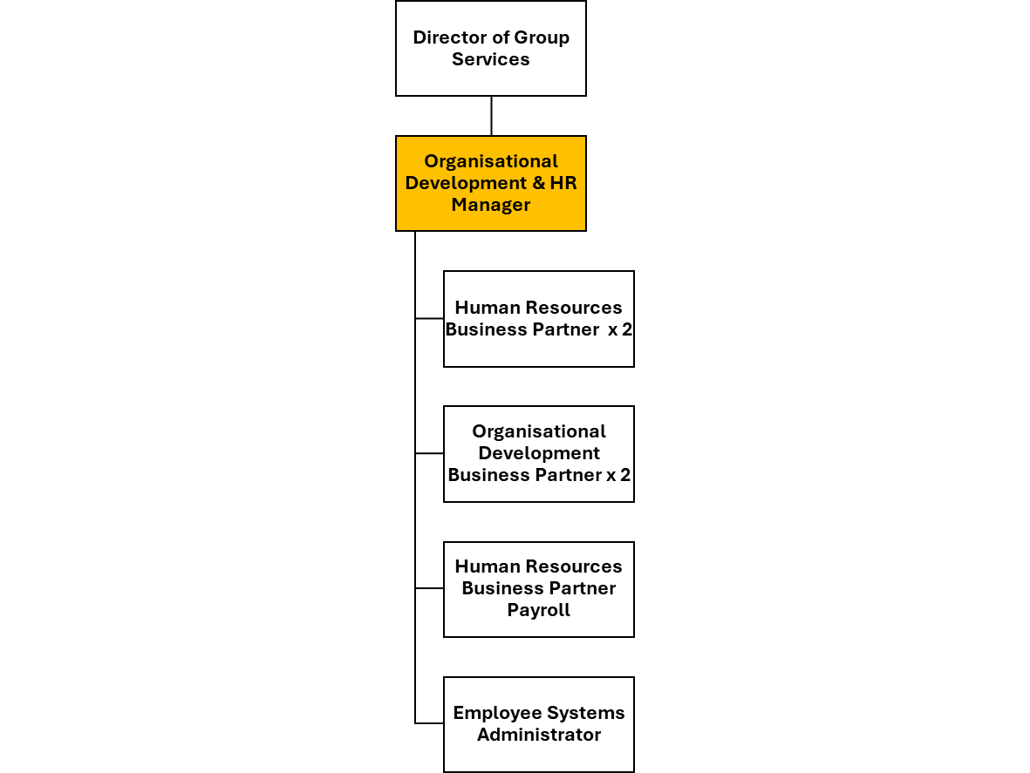

**Job Purpose:**

The Organisational Development & HR Manager will lead and inspire a team in the delivery of an excellent Organisational Development service.

They will lead the Organisational Development (OD) and Human Resources (HR) function of the ACHA group of companies so that it ensures compliance with organisational policy and procedures while meeting statutory and regulatory requirements.

They will be focussed on developing all employees within a Believe and Achieve culture, helping them reach their potential, promoting organisational growth and developing and maintaining positive working relationships across the group. They will also deliver efficient and robust HR and Payroll services.

The OD & HR Manager will be responsible for a programme of Organisational Development in accordance with the delivery of the group strategy, vision, values and desired culture.

Utilising data and insight, the OD & HR Manager will be responsible for continual improvement and delivery of solutions to improve the colleague experience.

**Objectives:**

* Provide the Senior Management Team and colleagues across the group with strategic information, advice and support on people matters which will influence the delivery of the organisation’s services.
* Deliver a high-quality people service to all departments, managers and employees of the ACHA group.
* Deliver an efficient payroll service to all employees of the ACHA group.
* Accountability for the development and delivery of a group wide training and development plan which meets the current and future requirement of ACHA’s business needs.
* Lead and inspire the OD and HR team to deliver leadership development, change management, performance management, succession planning and employee engagement.
* Embed a culture of collaboration across the group through development of the OD and HR business partner role.

**Strategy / Policy**

* Contribute to the development of the Group Services Directorate and Strategic Plans as required for their service area.
* Lead on the development of the group people policy and strategy, ensuring full operational procedures are in place and ensuring full compliance with legal and regulatory requirements.
* Develop and implement the group People Strategy Action Plan to improve overall organisational performance and effectiveness and to foster an organisational culture in keeping with the group’s broader strategic goals and values.
* Lead on the development and modernisation of the OD and HR team, developing strategy to align support to the needs of the group, individual companies and the local hub model for frontline services.

**Services**

Direct and manage the work of the OD and HR team to ensure that services are delivered to the highest standards, whilst supporting the team members to develop and achieve their potential. This will include:-

* **Culture Development**: Shape and nurture ACHA Group’s culture to ensure that it aligns with our core values of “simplify it”, “share it”, “own it” and “go for it”.
* **Talent Management and Workforce Development**: Develop employee development programs, recruitment, retention, and career progression strategies.
* **Assessment and Diagnostics**: Using tools and surveys, analyse the organisation’s health, identify gaps, and tailor interventions.
* **Annual Review Process** - Lead and oversee the annual review process and the development of a performance review framework.
* **Recruitment** - Lead on the recruitment of staff within the group, ensuring compliance with relevant legislation and excellent support for group managers.
* **Payroll** – Oversee accurate and timely processing of payroll, including relevant systems and processes, ensuring compliance with all HMRC and other regulations.
* **Customer and Stakeholder Engagement & Reporting -** Communicate OD and HR information and performance to senior management, board / committee members, and all internal and external stakeholders as required, ensuring information is tailored to the customer requirements.
* **Health & Safety -** Ensure all statutory and ACHA group regulations are followed, including Health & Safety, in order to protect customers, employees and the business interests of the Association.

**People**

* **Change Management** - Supporting ACHA Group employees to navigate and adapt to change effectively.
* **Leadership Development** - Build leadership skills, succession planning, and create effective leadership strategies to guide the ACHA Group
* **Team Building and Alignment** - Enhancing collaboration and communication amongst and between teams, ensuring they align with the ACHA target operating model and Corporate Strategy.
* **Team –** Clearly define the roles and priorities for the OD and HR team.
* **Training and development –** Identify training needs and develop programmes to support the ongoing learning and development of the OD and HR team.
* **Positive working with external relationships** – Establish and maintain positive and collaborative working relationships with external agencies, partners and contractors in the delivery of group OD and HR services.

**Believe & Achieve Activity**

To live Believe & Achieve values, so that every customer and colleague feels valued, and we achieve our full potential.

Comply with and promote the group's Vision and Values, Code of Conduct and professional standards by behaving in a professional manner at all times.

|  |  |  |
| --- | --- | --- |
| OD & HR Manager Skills | Essential | Desirable |
| Experience of providing professional advice and solutions on a wide range of organisational development and human resource matters | ✔ |  |
| Demonstrable experience of:   * Organisational Development and Change Management * Recruitment and Selection * Performance Appraisal * Training and Development * Discipline and Grievance * Remuneration and Benefits | ✔ |  |
| Excellent collaboration, influencing and interpersonal skills, to maintain effective working relationships with colleagues, other organisations and partners | ✔ |  |
| The ability to multitask, problem solve and work to short deadlines, prioritise and schedule workloads for self and other members of staff | ✔ |  |
| Strong IT skills including use of OD/HR related software | ✔ |  |
| Knowledge and ability to develop strong policies and procedures | ✔ |  |
| Proven ability in negotiating with Trade Unions, outside agencies and other partners | ✔ |  |
| Proven ability in analysing performance and reporting against agreed targets | ✔ |  |
| Strong skills in staff management including coaching and mentoring | ✔ |  |
| Ability to present information to a high standard, both in verbal and written form, to internal and external customers, senior management and board / committee members | ✔ |  |

|  |  |  |
| --- | --- | --- |
| OD & HR Manager Knowledge | Essential | Desirable |
| Educated to degree level in a related discipline | ✔ |  |
| Professional membership of the Chartered Institute of Personnel and Development | ✔ |  |
| A wide range of current legislative and technical knowledge in organisational development and human resource management | ✔ |  |
| Knowledge of industry trends and best practice | ✔ |  |
| Ability to set and manage budgets and financial awareness | ✔ |  |
| Good knowledge of data protection and handling confidential and sensitive information | ✔ |  |

|  |  |  |
| --- | --- | --- |
| OD & HR Manager Requirements | Essential | Desirable |
| Proven experience in a leadership or managerial role, exhibiting exceptional communication and interpersonal skills to manage and inspire a team effectively. | ✔ |  |
| Highly organised and capable of multitasking and thrives under pressure, ensuring the team operates seamlessly in a fast-paced environment. | ✔ |  |
| This role is hybrid therefore:   * A full UK driving licence and access to a vehicle for business use is required. * The job holder must be prepared to travel and work in other areas of Argyll & Bute when required | ✔ |  |
| Committed, flexible and adaptable approach to work requirements | ✔ |  |
| No role profile can cover every issue which may arise within the post at various times and the post holder is expected to carry out other duties from time to time which are broadly consistent with those described | ✔ |  |

|  |
| --- |
| Core Competencies |
| * Simplify It – Streamline Processes, Continuous Improvement, Empowerment * Go for It – Initiative, Ambition, Inspiration * Own It – Proactive, Problem Solving, Commitment, Feedback * Share It – Collaboration, Knowledge Sharing, Transparency |

Date approved: 17/03/2025

Director approval: Allan MacDonald

Chief Executive approval: Michelle Mundie