INFORMATION FOR APPLICANTS
for the post of
Senior Project Manager – Dumfries Learning Town £52,914 - £56,949

Contents
Introduction Page 2
Dumfries and Galloway: Our Region Page 3
Management Structure Page 4
Reporting Structure Page 5
Economy and Resources Directorate Page6
Education and Learning Directorate Page 7
Job Advert Page 8
Job Description Page 9
Person Specification/Assessment Page 14
Core Management Competency Framework Page 17
Main Conditions of Service Page 19
Application Process Page 20
Contact Us Page 20

Introduction
Thank you for your interest in applying for the post of Senior Project Manager – Dumfries Learning Town.
Dumfries and Galloway Council has set clear Priorities to - build the local economy, provide the best start in life for all our children, protect our most vulnerable people and be an inclusive Council.
We are committed to enhancing the lives of all the residents of Dumfries and Galloway. We are ambitious for our region, focused on supporting our communities to thrive and prosper, ensuring that we provide quality services that deliver our priorities. We value our 6000+ strong workforce in the work they do to achieve this.
Dumfries and Galloway offer its residents and visitors a quality of life second to none. We have beautiful coastal areas, stunning hills and vibrant market towns with excellent public services delivered by Council staff and other public agencies. We serve a population of approximately 150,000 across one of the largest regions of Scotland.

Dumfries and Galloway:

Our Region
- Population of 149,670 is steady but our demographic is changing
- Third highest ranked of the mainland council areas for rurality, with 19.6% of the population living in remote rural locations, and nearly half of all people (45.8%) living in areas classified as rural
- Recent population projections indicate that there will be 3,040 fewer people aged 18 or under living in the region by 2039, a decrease of 10%. The gap between older and younger populations is likely to widen over time
- The population aged 65-84 is forecast to increase by 25% by 2037 while the number of children and working age adults is projected to fall
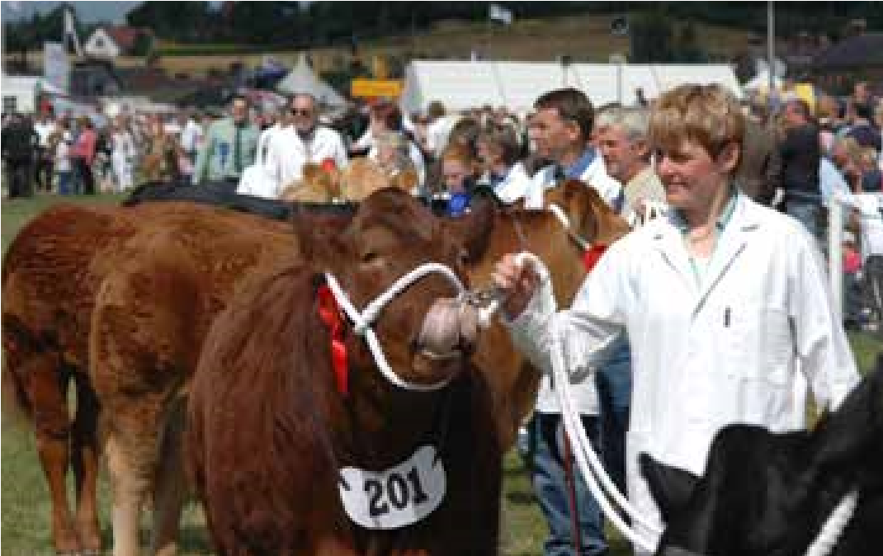
- Crichton University Campus is home to University of West Scotland, University of Glasgow and Dumfries and Galloway College offering both Higher and Further Education on a single campus

- Dumfries and Galloway has a strong sense of community with a number of operational community councils
- Dumfries and Galloway is home to the Eden, Spring Fling and Gael Force festivals not to mention Wigtown Book Festival. It also hosts
numerous traditional festivals including several common ridings
- The quality of the landscape has been recognised in the designation of three National Scenic Areas
(NSA)
- We are a key partner in the Regional Skills Investment Plan – South of Scotland Regional Skills Investment Plan
For additional information on our region go to www.visitdumfriesandgalloway.co.uk
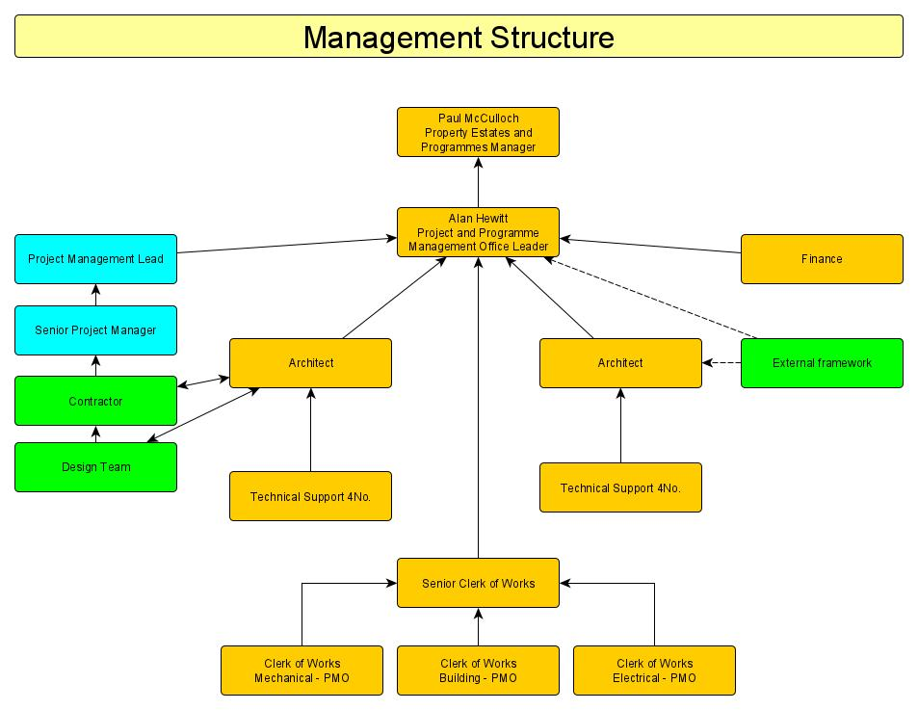
Dumfries and Galloway is the third largest council area in Scotland. This post will work with Property, Estates and Programmes within Economy and Resources and Skills, Education and Learning for the procurement, design and delivery of the final phase of Dumfries Learning Town. Key components of this are the replacement of Dumfries High School and refurbishment of Dumfries Academy including the relocation of Loreburn Primary School. The replacement of Dumfries High School forms part of the Scottish Governments Learning Estate Investment Programme.

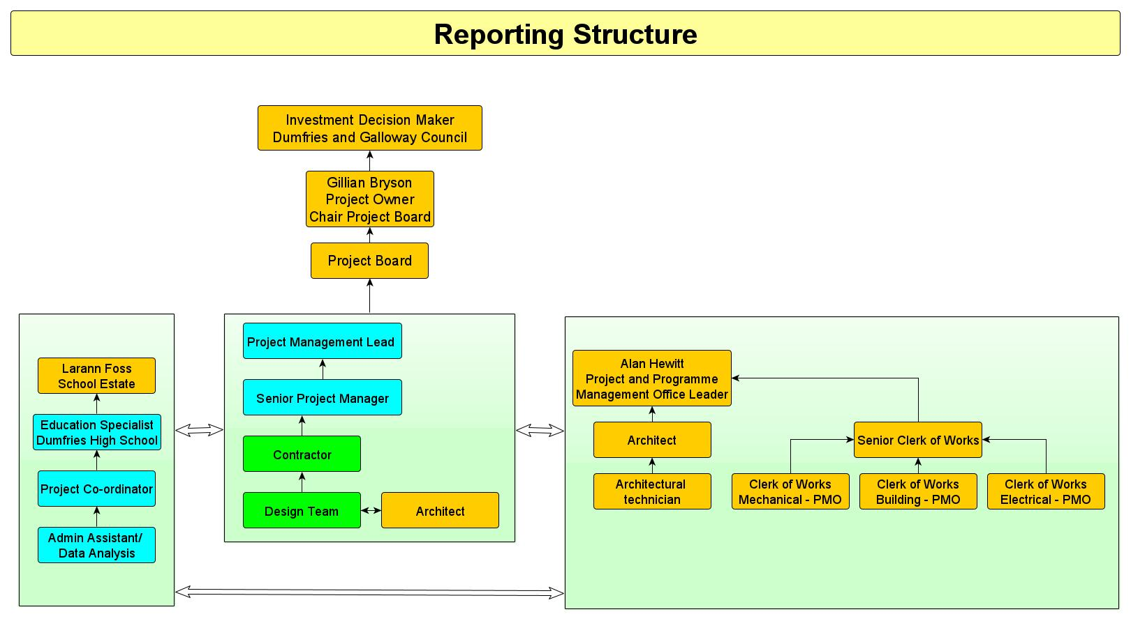

Economy and Resources – Property, Estates and Programmes.
The Property, Estates and Programmes department sits within Economy and Resources and is split into two teams, Project and Programme Management Office and Corporate Landlord who work closely together to manage and improve the Council’s built estate.

The Project and Programme Management is responsible for:-
- Review and approve project requests through the business case process and seek committee approval to allocate funding
- Develop standard project processes, tools and templates
- Overall management of project portfolio
- Establish and contextualise best practice methodology
- Develop common expectations and language (time/cost/quality)
- Allocate project staff and manage all projects centrally
- Be staffed with people who are highly skilled and that have suitable experience and qualifications in construction, project management and health and safety
- Provide training, certification and coaching to build core project management skills
- Track the status and achievements of all Council projects
- Establish and monitor project performance metrics
- Execute the physical delivery of the construction programme through external resource
- Adopt a standard methodology for the recording and management of project risk and risk reporting
- Advocate for project management and provide education within the organisation
- Manage project prioritisation and governance
- Have clearly defined reporting mechanisms
- Have clear linkage to the operational phase of any construction project (Corporate Landlord & Facilities Management)
- Deliver the smooth handover of construction projects including the collation and recording of all statutory certification, Health and Safety files and O&M manuals

The Corporate Landlord is responsible for :-
- Customer focused service
- Energy Management and Carbon reduction plan linked to climate emergency declaration
- Energy Bureau
- Fewer and Better Assets
- Estates and Asset Management including delivery of an annual Corporate Asset Management Plan
- Space standards and utilisation
- Updated building information that is managed
- Updated building condition information and cost which is managed
- Building Safety including Clerk of Works
- Clerk of Works team allocated to specific buildings
- Regular Statutory inspection and recording of buildings and plant condition
- Estates Statutory Compliance and Lead Occupier monitoring
- Building maintenance and management of all servicing and non servicing maintenance contracts and building asset registers.
- Management of contractors both in house and external
- Management of the PPP/DBFM estate
- Premises related Health and Safety requirements
- Disabled access requirements

Education and Learning Directorate
In Dumfries and Galloway we are committed to all of our children, young people and families to have an equal chance to fulfil their potential, a positive impact on what they will be able to do, who they may become and how they will contribute to our society. We know that children and young people have good experiences in our schools and early years establishments and have good outcomes from their learning.
The facilities used to deliver education play a vital role in meeting the vision and aims of the service and it is vital that all investment creates schools fit for the 21st century, which serve their community within the most economically advantageous solution.

The replacement for Dumfries High School, is a significant part of the concluding phase for Dumfries Learning Town. It requires dedicated resource which brings together all the required and appropriate skills and expertise from specifically the Education and Learning directorate and the Property, Estates and Programmes team, along with other Council wide resources at key stages.

Managed by the Project and Programme Management Office Leader, the position of Senior Project Manager working to the Senior Responsible Officer will work closely with these two departments at the relevant stages for the delivery of this multi million pound project.

It is envisaged that interviews for this post will be carried out in early December 2021.

Further Information
You can find more information about the Council by visiting the following page Dumfries and Galloway Council: Council and government.
You will find information on the Council Business Plans and how our current services are performing by clicking on the following link
Dumfries and Galloway Council: Council performance.

Senior Project Manager Dumfries Learning Town £52,914-£56,949
This position provides an exciting opportunity for an experienced and pro-active Project Manager to work as part of the team in the delivery of Phase 2 of Dumfries Learning Town, delivering school facilities fit for the 21st century.

The successful candidate will be responsible for working as an integral part of the team to deliver the procurement, design, construction, commissioning, and handover of a new replacement Dumfries High School and for the refurbishment of Dumfries Academy which includes the relocation of Loreburn Primary School. Working within Property Estates and Programmes and reporting directly to the Project Management Lead the successful candidate will work as part of the wider team to deliver innovative, modern, energy efficient facilities for our pupils and staff.

The successful candidate will be an experienced project manager with proven project management skills across the construction sector, with the ability to work to deadlines whilst under pressure.

You will be educated to degree level or equivalent, preferably have professional membership at an appropriate level of a recognised body (ARB, RIAS/RIBA, RICS, CIOB) and have a recognised Project Management Qualification. You will have significant experience in the delivery of capital projects across the public sector including the management of consultants and contractors.

This is a fixed term position for a 4-year period. Benefits include an attractive relocation package of up to £5,000 and access to the Local Government Pension Scheme which includes free life cover.

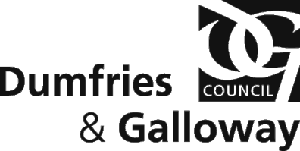
JOB DESCRIPTION

Job Title:  Senior Project Manager Dumfries Learning Town (DLT) Phase 2 |  |  | Ref No: | JE Ref: U920
Department:  Education |  | Band: (14) | Location:  Dumfries
Responsible To: | Project Management Lead
Responsible For: | Line management responsibility for project team.
Job Purpose: | The postholder will support the Project Management Lead by carrying out the following:  To successfully deliver Phase 2 of Dumfries Learning Town project on behalf of Dumfries and Galloway Council, through the new project request, to procurement, construction and delivery including all testing, commissioning and handover.  This postholder will utilise project management methods in line with current Scottish Government SCIM guidance and industry recognised best practice. This will lead the development of strategic plans that provide the overall aims and policies for the project and ensure that individual projects sit within the operational framework that support this. This will include integration within the Council’s Project and Programme Management Office.  The post-holder will deliver these projects to be undertaken within the project, working with the Scottish Futures Trust, DGC PMO and Scottish Government colleagues through the South West Territory hub to take forward planning and procurement. This work will vary in size and complexity and will include new build, refurbishment and Estate Strategy Planning associated with these capital building projects.
Main Responsibilities: | The postholder will be responsible for and will undertake:  - The post holder will lead, develop, and motivate a team to deliver the projects (internal and external individuals, consultants, and companies).  - To lead on the delivery of a programme of projects and estates investment to agreed cost, budget, and specifications.  - To ensure the necessary operating procedures are in place and governance to seek decision making from the necessary Project Board, Committees and Full Council.

- To be responsible for the achievement of the agreed strategic objectives within the project by leading and directing negotiations and consultations within the South West Territory hub and internal and external consultants to facilitate the organisational management and control of the proposed projects, and to realise the outcomes by focusing on benefits.

- To ensure compliance with South West Territory Hub processes including but not limited to New Project Request Forms, Stage 1, Stage 2, and Financial Close acting as Client Representative discussions on behalf of the Council.

- To ensure compliance with the Council’s standing Financial Instructions and PMO processes regarding the tendering, contracting and management of works.

- To deputise when required for the Senior Responsible Officer in representing the Council in discussions and collaborative initiatives across the project. Liaising and communicating with other Local Authorities to maximise benefits to the Council.

- To ensure robust development of the Authorities Construction requirements and ensure delivery of the projects in line with the Scottish Governments funding parameters.

- Ensuring compliance with processes and procedures including delivering to project conditions, risk management and Key Stage Review Processes.

- To facilitate regular informal and formal meetings with key stakeholders to ensure conflict, issues and constraints are minimised and the optimum strategic solution is identified and implemented. This involves the management of highly complex relationships where issues between stakeholder groups can be contentious and difficult to manage. Overall agreement must be reached and the postholder must be able to negotiate with large groups of stakeholders, possibly with opposing views where elements of hostility between groups must be managed and directed proactively to serve the project objectives.

- To maintain and develop in line with PMO processes a configuration management system that will provide the organisation and control for all control files to demonstrate that the programme and associated projects are designed and implemented in accordance with current guidance, best practice and will meet governance standards.

- Operational responsibility for Health & Safety in relation to the delivery of Projects

- It is crucial that the postholder escalate knowledge of time and or cost overruns along with any proposals for contingency planning to the Senior Responsible Officer to inform them and to facilitate their decision-making process to allow them to discharge their responsibilities.

- The post-holder will be responsible for monitoring all projects during the procurement process, including close working with legal and procurement colleagues to ensure that all relevant standards and contract elements are adhered to.

- To comply with all Data Protection, Freedom of Information, IT Security, Health and Safety policies and guidance so that statutory requirements are met.

- Demonstrate excellent verbal and written communication skills and be able to liaise and discuss project management with a wide range of stakeholders who may include but not limited to:
  - Elected Members.
  - Local Authority Chief Executive(s) and Senior Management representatives.
  - Hub National Programme Development Office.
  - Private Sector Development Partner.
  - Community Planning Partnership Board.
  - Finance Managers.
  - Service Planning and Community Development Managers.
  - Asset & Estate Managers.
  - Legal Teams.
  - Scottish Futures Trust
  - Learners, Staff, Teachers and Community; and
  - Communications & Media Managers.
Job Activities: | - To identify the need, seek approval and procure external advisers in compliance with Council and European Union requirements or through the South West Hub, or other procurement routes as required.  - To work with and advise Education Services senior management staff, school staff, other areas of Dumfries and Galloway Council and other external bodies to assess need, establish and agree client briefs.  - To work with stakeholders to lead on the development of policies and procedures in relation to establishing learning and teaching environment strategies and ensure their adoption across Dumfries and Galloway.  - To lead on the identification and delivery of a suite of master documents to support effective project delivery, including but not limited to project plans, project execution plans, project programmes, reporting formats, risk registers and post occupancy evaluations.

  - To devise and seek approval for a specific sustainability strategy for these projects including delivery of Dumfries High School meeting the energy use requirements of funding.

  - To analyse complex information from a variety of different sources to collate and maintain knowledge around best practice in learning and teaching forums.

  - To manage construction contracts on behalf of the Council

  - To represent Dumfries and Galloway Council on relevant national forums where required.

  - To establish and maintain effective working relationships with other Council services and departments.

  - To lead on the planning, design, and co-ordination of complex financial monitoring and programmes to ensure delivery to brief, meeting user needs.

  - To liaise effectively with learning and teaching colleagues to deliver innovative change management programmes.

  - To ensure lessons learned and post occupancy evaluations are undertaken, results are fed back into long term future planning and disseminated across the service.

  - To organise and lead meetings.

  - To draft reports and produce or arrange for the production of master documents, ensure they are kept updated and present to the appropriate audience.

  - To regularly meet and communicate with school management, users, and stakeholders.

  - To record key events and service information for the purposes of audit.

  - To recruit, lead and manage a project team to deliver the projects.

  - To perform the role commensurate with a Client-side project manager.

  - To identify any opportunities to work closely with PPP, Estate, and ICT teams to support a coherent work approach.

  - To be responsible to ensure the necessary statutory consultation processes are obtained to allow the projects to be delivered.

.

- To lead on effective and innovative methods of communication

- To ensure all utility connection issues relating to each site are clearly identified and addressed.

- To ensure that both design and construction quality management is embedded into all project processes.

Performance Management: | The job activities listed are not exhaustive and may be added to or amended consistent with the job purpose.  - To manage your own performance and any staff you may be responsible for in accordance with the Council’s values of Customer First, continuous improvements, openness and honesty, local decision making and team working.  - To achieve the agreed performance targets detailed in the work plan and contribute to performance appraisal activities.  - To manage your own performance in compliance with all Codes, Regulations and procedures including Code of Conduct, Health and Safety and Governance.  - To manage risk, promote risk awareness and prioritise work considering the risk analysis.  - To actively commit to the Council’s equality and diversity vision statement and associated policies that promote fairness and equality and celebrate diversity, in dealing with colleagues, clients and service users.  - To take all reasonable measures to limit carbon emissions and reduce energy/ resource consumption when undertaking work activities.
Prepared by: | Property Estates and Programmes Manager | Date:  12/02/2021

PERSON SPECIFICATION AND ASSESSMENT FORM

Candidate Name |  | Post Ref No
Post Title | Senior Project Manager, Dumfries Learning Town Phase 2 | JE Ref |  |  | U920
Service | Education | Band |  |  | 14
Base | Dumfries
References | Name |  | Good | Fair |  | Poor
1
2

Requirements  Essential (E) or Desirable (D) | E | D |  | Requirements  Essential (E) or Desirable (D) | E | D
1. Education and Training | Score |  |  | 4. Knowledge | Score
Educated to SCQF Level 9 or equivalent, in a relevant technical discipline, such as Architecture, Surveying or Construction  Project Management. | E |  |  | Microsoft Office and relevant project programming software | E
Professional Membership at an appropriate grade of a relevant, recognised body (e.g., ARB, RIAS/RIBA, RICS, CIOB). | D |  |  | Knowledge and working experience of best practice of project governance arrangements including the Scottish Governments Capital Investment Manual | E
Records of ongoing continuous professional development to comply with the standards set out by the professional body.  A project or Programme management qualification. | E  D |  |  | Knowledge of relevant and new methods of innovative project management and delivery.  Detailed knowledge of critical path programming and project review processes. | E  E
Membership of the Association of Project Safety.  NEBOSH National Construction Certificate.  IOSH Managing Safely. | D  D  D |  |  | Detailed knowledge of identification and management of stakeholder engagement.  Detailed knowledge of the creation of project stakeholder communication plans. | D  E
 |  |  |  | Knowledge of construction procurement routes including open, restricted, negotiated, and competitive dialogue processes. | E
 |  |  |  | Knowledge of processes in ensuring design and construction quality. | E

2. Experience | Score |  |  | 5. Personality Factors | Score
Substantial experience working on a school building project or programme or similar with other Public Authorities  Substantial experience working on a PPP/PFI/HUB or similar funded project or programme within the public sector.  Direct experience of leading development management for several projects  Direct experience of being the lead manager in the preparation of business cases and project briefs  Direct experience in managing consultants including the approval of consultant deliverables  Direct experience in chairing Project Boards, securing procuring authority approval for project budget and scope.  Direct experience in managing risk within a project environment  Experience of working with internal stakeholders and external consultants to ensure project delivery.  Experience of development and delivery of an innovative projects including change management.  Experience of budget development and financial monitoring for programmes  Ability to set up and maintain suite of project management procedures.  Experienced lead in commercial business management role and in dealing with contractual disputes or claims  Experience in leading procurement management and in managing construction contracts | E  D  E  E  E  D  E E  E  E E E  E |  |  | Confident  Strong negotiating and conflict management skills  Able to lead and motivate a team  Good time management and ability to prioritise  Highly developed inter-personal skills Innovative and creative  Excellent organisational skills  Able to solve complex problems and issues  Able to work in a highly pressurised environment  Ability to motivate and develop others.  Ability to engage complex and demanding stakeholders. | E E  E E  E E E E  E  E E

3 Skills and Abilities | Score |  |  | 6. Other Requirements | Score
An ability to summarise complex and diverse subjects in clear Plain English  An ability to take a broad view and to understand the Council’s strategic goals and priorities  Be able to set clear objectives and targets as well as plan/schedule/review a wide range of projects and activities  Able to lead or work in partnership with internal and external clients and advisers to ensure project delivery  IT literate | E  D  E  E  E |  |  | Be able to work under pressure to meet deadlines  Willingness to work evenings and weekends where required  Ability and willingness to handle sensitive data and maintain strict confidentiality  Full driving license | E  E  E  E

Core Management Competency Framework
The following table provides a reference for the Core Management Competencies identified for Senior Managers in Dumfries & Galloway Council.
Leadership | Strategic Thinking And  Planning | Delivering Results
Creates and secures commitment to a clear vision  Initiates and manages change in pursuit of strategic objectives  Is visible, approachable and earns respect  Inspires and shows loyalty  Builds and supports a high performing team  Acts decisively having assessed the risks  Accepts responsibility for actions of the team  Demonstrates the high standards of integrity, honesty and fairness expected in public services | Develops and influences strategic aims, anticipating future demands, opportunities and constraints  Demonstrates sensitivity to Members’ needs and to wider political and departmental issues  Contributes effectively to strategic thinking of senior management team  See relations between complex inter-dependant factors  Reconciles day to day demands with long term objectives  Translates strategic aims into practical and achievable plans  Takes decisions on time, even in uncertain circumstances | Organises work processes to deliver on time, on budget and to agreed quality standards  Defines results taking account of customer’s needs  Manages relationships with customers/other stakeholders effectively  Strives for continuous performance improvement and encourages others to do so  Demonstrates high level project management skills Assesses and manages risk  Monitors performance and incorporates feedback in future plans
Management Of People | Communication | Management Of Financial  And Other Resources
Makes best use of skills and resources within team  Develops staff to meet challenging organisational needs  Establishes and communicates clear standards and expectations  Delegates effectively, knowing when to step in and when not to  Gives regular face to face feedback and recognition  Addresses poor performance  Builds trust, good morale and teamwork, responds to feedback from staff  Secures commitment to change through appropriate involvement of staff | Chooses methods of communication most likely to secure effective results  Negotiates effectively and can handle hostility  Is concise and persuasive orally and in writing  Listens to what is said and is sensitive to others’ reaction  Demonstrates presentational and media skills  Is comfortable and effective in a representational role  Builds, maintains and uses an effective network of contacts  Develops appropriate language skills | Challenges existing practices and leads initiatives for new and more efficient use of resources  Secures value for Council taxpayers’  money  Negotiates for the resources to do the job, in the light of wider priorities  Use management information to monitor/control resources  Manages contracts and relationships with suppliers effectively  Demonstrates commitment to using IT as a resource

Personal Effectiveness | Intellect, Creativity And  Judgement | Expertise And Professional  Competence
Shows resilience, stamina and reliability under heavy pressure  Adapts quickly and flexibly to new demands and change  Manages own time well to meet competing priorities  Takes firm stance when circumstances warrant it  Is aware of personal strengths and weaknesses and impact on others  Shows commitment to own  personal and professional development  Offers objective advice without fear or favour  Pursues adopted strategies with energy and commitment | Demonstrates a creative and constructive approach to problem solving  Homes in on key issues and principles  Offers insights and generates original ideas with practical application  Analyses ambiguous data and concepts rigorously  Displays confidence in own judgement but responds constructively to alternative ideas  Encourages ideas, initiatives and innovation in others | Operates effectively within the  political and local government framework  Earns credibility and influences through depth and breadth of expertise  Ensures that decisions are informed by relevant technical/specialist expertise  Accepts personal responsibility for quality of professional work  Gives professional direction to others  Seeks and applies best practice from other organisations

Main Conditions of Service
The following list of conditions is not exhaustive and is provided only as a synopsis of issues commonly raised by applicants for employment with the Council.

Salary scale | £52,914.00 to £56,949.00
Payment frequency | Salary paid direct to bank or building society on 15th of each month.
Holiday entitlement | 23 days rising to 28 days after 5 years continuous local government service (at the start of the leave year). In addition there are 11 general and public holidays, 7 of which are fixed.  Additional annual leave can be purchased.
Flexible Working Arrangements | Flexible working arrangements are applicable.
Pension | The Local Government pension scheme is available. Employee contributions are based on level of pay.
Notice period | Two months’ notice on either side.
Relocation package | Applicable.
Fixed Term | The post will be a fixed term appointment for the 4-year duration of the project
Interview expenses | Interview expenses are included.
Political restriction | This post is not politically restricted under the terms of the Local Government and Housing Act 1989.

Application Process

Method of Application
Please complete in full the Council’s Application form on the Council’s recruitment website (www.myjobscotland.gov.uk/councils). In your application, please provide an outline of your experience, with particular focus on the requirements of this post as set out in the job description and person specification. You should also complete the Equal Opportunities Monitoring form, which will assist us to maintain fairness in recruitment and employment practices.
Please note that CV’s will not be accepted, and the Council’s Application Form must be completed in full for your application to be considered.
As part of the application process, you will be required to provide the names, addresses and telephone numbers of two referees, one of which must be your current or most recent employer.
The Closing date for the post of Senior Project Manager is Friday 17 December 2021. We are unable to accept applications after the closing date. Interviews will be scheduled for week beginning Monday 3 January 2022

Contact Us
The information referred to in this document is intended to provide you with the means to make an informed and considered application.
For an informal discussion, please contact Paul McCulloch, Property, Estates and Programmes Manager on 07867206287 or paul.mcculloch@dumgal.gov.uk

