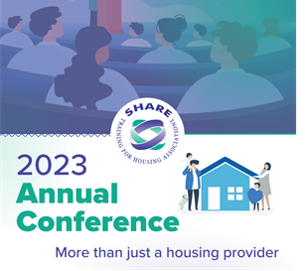

24th to 26th March 2023 – Westerwood Hotel in Cumbernauld, Glasgow

Weekend delegate
Booking form

BLOCK CAPITALS PLEASE
Booking Contact:
Organisation Name
Address
Telephone No:
Email Address:
Date:
Please read the booking instructions carefully.

- You do not need to confirm your booking with a cheque. Organisations will be invoiced.
- Please ensure that any special requirements are clearly documented in the table provided. This will help meet your delegate requirements but please be aware there is a limited number of accessible rooms.
- All bookings will be acknowledged - if you don’t get this, please contact us to ensure your booking is being processed.
- You can make changes to your booking free of charge until 24th January 2023. Thereafter there will be a charge of £40.00 per instance of change e.g., five changes in the one request will incur a cost of £40.00 however if you request five individual changes then the cost would be £200.00.
- Cancellation of a full booking from 3rd February 2023 will incur the full cost of booking. At this point we have confirmed rooms and catering etc.

Delegate Details
Full Name  (PLEASE PRINT) |  | Staff/ Com | Coach  Y/N | If the delegate has any allergies/food intolerances or accessibility requirements, please provide details to help us ensure we can meet their needs
SHARING WITH (if applicable)
1
2
3
4
5
6
7
8
Example Joe Bloggs | Jane Bloggs | C | Y | √ see special requirements table for explanation

Special Requirements i.e., disability, food allergies etc (please continue on separate sheet if required)
Name | Accessibility requirement | Dietary: Allergies/food intolerances
Example Joe Blogs | Wheelchair user – requires walk in shower (Please ensure a full description of accessibility requirements are included for us to ensure we can provide what the delegate requires) | Nut allergy

Costs
Costs | Costs – member | Costs – non member | Nos | Total
Early bird (until 23rd January 2023) Single occupancy per person (1 room with 1 double bed) | £730 | £870
Early bird (until 23rd January 2023)  Double occupancy (2 people sharing one room/twin beds) per person | £630 | £780
Single occupancy per person (1 room with 1 double bed) (full price from 24th January 2023) | £830 | £990
Double occupancy (2 people sharing one room/twin beds) per person (full price from 24th January 2023) | £720 | £890
Return Coach per person | £50 | £50
 |  |  | Total

Please sign below to confirm your booking and that you are aware of the booking instructions.

Signature _______________________________________________________

Date _________________________________________________
Thank you for your booking.

